Investigation of DART Network's
viability to be used to study the
Thermohaline Circulation
Leon Huang (297 151 994)

Table of Contents

Table of Contents 2
List of Figures 3
Abstract 4
Acknowledgements 4
Introduction 5
Literature Review 6
Thermohaline Circulation Structure 6
Thermohaline around New Zealand 7
Data Availability 8
Objectives and Methods 10
DART Network 10
Objectives 11
Methods 11
Results and discussion 12
Sensor Comparison 15
Data reliability & Argo Data 16
Data Patterns 17
Conclusion 18
List of References 19

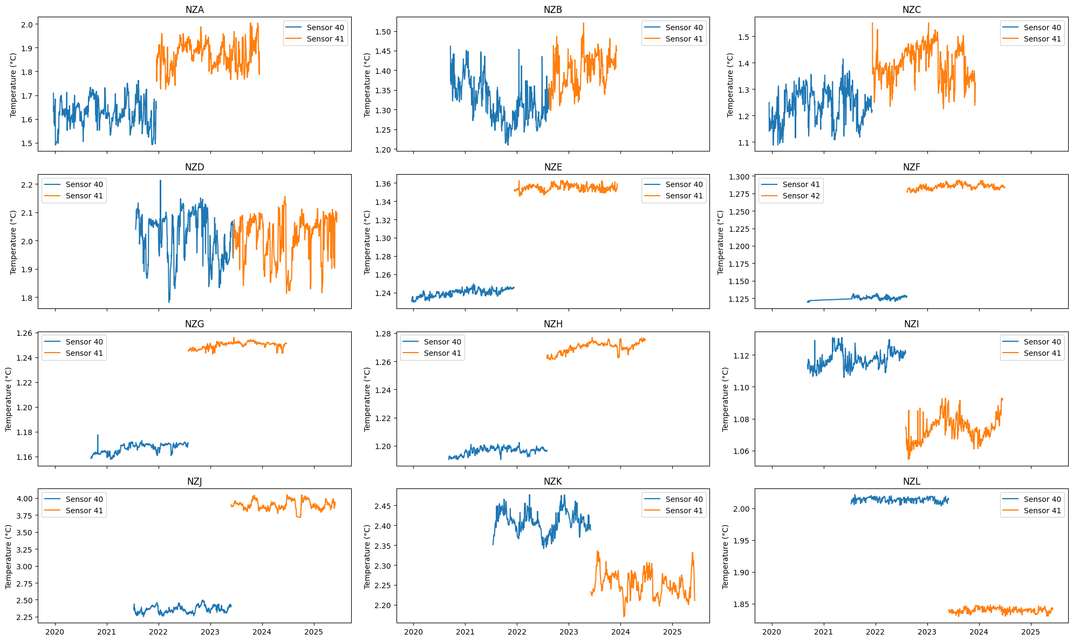
List of Figures
Figure 9 – Comparison of sensor at each station with outliers removed

Abstract
Understanding the deep ocean is critical for studying a changing world, but deep ocean data remain spatially and historically limited. The GeoNet’s Dart Network is an early warning detection system near New Zealand. The bottom pressure recorder has a temperature sensor placed inside the device, recording internal temperature. The objective of this report is to investigate the DART Network temperature data and determine if it can be used as the water temperature. Anomalies and patterns in the temperature data were investigated across different sensors and timescales, as well as compared to reliable Argo sources. The result showed that there was a lot of noise, but also useful areas in the data. A sinusoidal pattern was captured in the diurnal cycle, and a similar temperature range to Argo data suggests that the DART network is able to capture some temperature changes, despite having an incorrect temperature base. The data is less reliable when used below an hourly timescale, as the network seems to have some type of hourly process that consistently influences the temperature data on a small scale.

Acknowledgements
I would like to acknowledge Melissa Bowen for supervising and providing me with the idea for this research project.

Introduction
The Thermocline circulation is how the ocean distributes heat, salt, nutrients and marine life all around the world. Understanding the Thermohaline circulation is crucial for predicting climate patterns, sustaining marine ecosystems, and monitoring global heat transport. Despite its significance, data on deep ocean currents remains limited due to the vast and deep nature of the ocean.
Advancements in technology have led to greater data available through the Deep Argo Program, deep mooring techniques, and occasional ship casting and survey data. However, coverage and historical data of the ocean floor remain limited. An existing deep ocean monitoring system, the “Deep-ocean Assessment and Reporting of Tsunami” (DART) Network, has some potential to increase deep ocean visibility.
The DART Network is an early Tsunami detection system; it consists of a Bottom Pressure Recorder (BPR) on the ocean floor to measure changes in water pressure. On the BPR is also an internal temperature data sensor. This research project investigates the DART Network internal temperature data and its viability to be used as temperature data for the deep waters in that area. If possible, it will increase the historical temperature data available and increase the data coverage along the ocean floor.

Literature Review
The Thermohaline Circulation, often referred to as the Global Conveyor Belt, is a series of large, interconnected ocean currents that control the movement of the world’s ocean water. It transports warm surface water to deep underwater currents along the ocean floor, sometimes taking thousands of years to resurface. The thermohaline circulation spans across the 5 oceans, redistributing heat, salt, nutrients, dissolved gases, and marine life around the world. (Pauthenet et al., 2019).

Thermohaline Circulation Structure
The circulation is mainly driven by the differences in water density, which is a function of the water’s temperature (thermo) and salinity (haline). Water density is lowest towards polar regions and the bottom of the ocean, where temperatures are typically lower and salinity is higher. Although this is not always the case, such as with subtopics that have the saltiest surface water, despite the polar water still being denser. This is due to temperature having a strong influence on density compared to salinity. (Zika et al., 2015).
The structure of the Thermohaline Circulation can be understood through the “push” and “pull” theories that drive the circulation, as described by Lozier (2010). The theory is a way to categorise the driving forces of the Thermohaline Circulation. The “push” theory suggests that the circulation is pushed by deep water formation in the polar regions, as new deep water is created, it pushes existing deep water through the circulation. Deep water forms when sea ice is created, when water freezes, only pure water is taken out of the ocean. The salt content is left behind, making the remaining local water saltier. Combined with the low temperatures of the polar regions, the water becomes dense and sinks to the bottom of the ocean.
When deep water forms in the North Atlantic, it is known as the North Atlantic Deep Water (NADW), which sinks and travels south along the western coasts of North America and South America, as shown in Figure 1. Deep water often travels along the western side of continents due to the Coriolis Force; scientists have referred to these currents as the Deep Western Boundary Currents (DWBC). It will continue on this DWBC under it reaches the Antarctic Circumpolar Circulation (ACC). There is another deep-water formation occurring in the Antarctic, forming the Antarctic Bottom Water (AABW), which also joins the ACC.
ACC given by the name, is a current that circumnavigates the Earth. It is a unique current in that it has both a surface and a deep current that flow in the same direction. Due to the lack of landmass, there are only a few places where the ACC deviates, one is South of Africa, and the other is along New Zealand. Bottom water leaves the lower limb of the ACC in these locations and creates the DWBC along the African continent and the Pacific Islands.
Along these two DWBC, upwelling occurs, causing the deep water in the lower limb to rise to the surface. The “pull” theory here suggests that it is the forces causing this upwelling of the Thermohaline that are also pulling the rest of the circulation along. There are many factors for upwelling, a common one is the wind-driven Ekman transport, other factors are the warmer latitude, causing the water to naturally warm and rise.
After the deep water has upwelled, it travels along the surface eastward, driven by the prevailing winds in the low latitudes. It will continue until it reaches the Atlantic Ocean, at which point it will head North to fill in the surface water that had been used in deep water formation in the North Atlantic and continue the cycle.

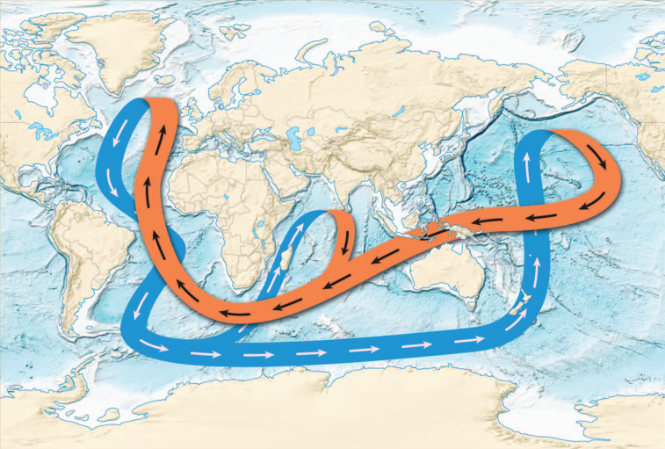
Figure 1. Diagram of Thermohaline Circulation. Orange represents warm surface water, while blue represents cold deep ocean water. [Adapted from Lozier (2010).

Thermohaline around New Zealand
Temperature and salinity are the main driving forces of the Thermohaline. However, there are many other influences on the thermohaline circulation, such as bathymetry, wind currents, climate modes, the Coriolis force, landmass, and numerous other global and local factors that affect specific currents.
This research paper will focus on the Thermohaline Circulation around New Zealand. New Zealand is situated near the strongest ocean current on Earth, the Antarctic Circumpolar Current (ACC), and serves as the entry point for the Deep Western Boundary Current (DWBC). The ACC is a current that circles the entire Antarctic continent. Unlike other currents, the ACC encompasses the entire vertical water profile, consisting of both a warmer surface current and a cooler deep current that flows eastward (NIWA, 2008).
On the east side of New Zealand sits another important current of the Thermohaline Circulation, the Deep Western Boundary Current (DWBC). This current takes Antarctic Bottom Water (AABW) from the lower limb of the ACC around the east side of NZ and into the DWBC in the Pacific Ocean, where it will resurface during upwelling (NIWA, 2008).
When sea ice forms at the coast of Antarctica, only pure water is frozen while the salt is rejected. This salt sinks into the deep ocean, increasing the salinity and density of the deep waters. Katabatic winds from the Antarctic Mountains, comes down and blows away newly formed sea ice, creating a continuous cycle. This cycle of increasing salinity and decreasing temperature causes the coastal water to sink due to density and travel northwards, providing the dense water for the AABW (Silvano et al., 2023).
The reason the ACC deviates around New Zealand is due to it southern position but also the local bathymetry. This mainly refers to the wider submerged continent New Zealand sits upon, Zealandia. Distinguished by its higher elevation above the surrounding oceanic crust (Mortimer et al., 2017).
As a sunken continent, its elevation adds to the bathymetry, influencing surrounding currents. South of New Zealand is the Macquarie Ridge, an underwater mountain ridge that is an extension of the on-land Southern Alps. The ridge sits along the ACC path, disrupting it and serving as the entry point for AABW into the DWBC. (NIWA, 2008).
East the New Zealand is the Campbell Plateau and the Chatham Rise. These are elevated pieces of unwater landmass extending eastward, outlining the sunken Zealandia continent. After the AABW passes through the Macquarie Ridge, the bathymetry deflects it northeast toward Campbell Plateau. Due to the Campbell Plateau's elevated height, the AABW flow along the edge, concentrating and intensifying the flow. This continues north along the Chatham Rise, reaching the eastern edge where it will enter the Pacific Ocean, providing the dense water in the DWBC (Carter, 1997).

Data Availability
These areas play a crucial role in the heat, salt, nutrient, and biological processes surrounding New Zealand, and are worth researching and measuring. Data on the Thermohaline Circulation is abundant for certain areas, while it is extremely scarce in others. Technology such as satellites enables surface current data to be abundant, but limited accessibility for the deep current on the ocean floor (Carter, 1997).
This research report will be about data near New Zealand, and as such, we will look at the data availability near. The most abundant data available, including around the world, is sea surface temperature data from satellites. This type of data collection is extremely efficient and has a large area of coverage. Radiation emitted from an object is dependent on its heat content, as long as the satellite has a line of sight of the ocean, it is able to measure it temperature. This type of data is collected and openly available from many sources, such as NIWA (n.d.-b) or MetService (n.d.).
Another type of data available around New Zealand is from Argo. Argo are devices at sea that can float at various depths up to 2000m below the surface. These devices can record various information, including temperature and salinity, at different layers before resurfacing and transmitting this information to satellites. Argo data is part of the international Argo Program that standardises and opens source all the information collected around the world. There are around 3,900 active Argo, and it is by far the greatest source for below-surface data. The New York Times have described the Argo Program as “one of the scientific triumphs of the age”. But even Argo has their limitations, the typical Argo depth is limited to 2000m, and the position of the Argo is dependent on the waves and cannot take continuous stationary samples. There is a Deep Argo Program that can reach depths of 6000m; however, currently there are only ~200 active Deep Argo and even few near New Zealand (Argo Program, n.d.).
Mooring is another data collection technique that has been used around New Zealand. This involves attaching measurement devices to a chain connected to a buoy and an anchor. The device is left at stationary point at sea for a period of time, collecting a vertical profile of information. This has been done at the Macquarie Ridge, Campbell Plateau, and Kermadec Trough near New Zealand. The limitation of Mooring is the small area of coverage and is extremely cost & labour intensive. Additionally, many places are too dangerous to use mooring techniques, such as the ACC with strong waves and stormy weather (NIWA, 2008).

Objectives and Methods
GeoNet is a New Zealand’s national geohazard monitoring system, one of their systems is the DART network designed to monitor tsunamis. It does this through a device the bottom of the ocean floor that detects sudden changes in pressure, additionally it also has a temperature recorder. My research supervisor, Melissa Bowen (2025), was first to notice that temperature data listed was not accurately labelled. The temperature sensor was placed inside the device housing unit, see figure x, and did not have direct contact with the water. The objective of my research project is to investigate this temperature dataset and its potential viability to be used as a temperature measurement for the surrounding deep water.

DART Network
The Deep-ocean Assessment and Reporting of Tsunami (DART) Network uses devices on the sea floor to detect Tsunami as a part of an early warning system. The device on the sea floor is called the Bottom Pressure Recorder (BPR), which uses the change in water pressure to detect incoming Tsunamis, typically intended for use after natural events such as Earthquakes. When a change is recorded, the BPR uses an acoustic signal to communicate with a buoy, which in turn uses a faster electromagnetic signal to communicate with satellites, which transfers all this data to an operating centre. (Geonet, n.d.).
The BPR has two modes. In its normal mode, it records data samples in 15mins intervals; the samples are packaged and transmitted every 6 hours. Once a significant change in water pressure is detected, it switches to event modes. In event mode, data is sampled every 15 seconds and is immediately transmitted; this continues for the next 3 hours before switching back to normal mode. It should also be noted that it does record temperature data but is not transmitted; it is stored on the BPR and is only available after maintenance, which occurs once every two years.

Objectives
My research objective is to investigate the viability of using the DART Network’s BPR internal temperature data as a measurement for the temperature of the surrounding deep water. The research objects were:
- Investigate the temperature pattern during Event Mode
- Investigate the temperature spike at the beginning of the data to see if a vertical temperature profile be created
- Investigate the differences in temperature between sensors
- Investigate the data reliability by comparing it to Argo data
- Investigate any natural and human patterns in the data

Methods
Most of the investigation will be conducted using one sensor at one station for the sake of time and efficiency. Since I am motivated to investigate the dataset to study the Thermohaline, the station closest to it was chosen. There are five stations close to New Zealand; however, all 5 of these are north of the Chatham Rise and are not along the edge where the AABW travels. Station NZE was used because it is the easternmost of the five and will most likely be the closest to the DWBC as it travels towards the Pacific Ocean.
- The data used in this investigation is from GNS Science (2023) as part of the New Zealand GeoNet program sponsored by NHC, LINZ, NEMA and MBIE. I used the GeoNet API to access the data, while using the Python packages of pandas and matplotlib to graph and do correlation analysis on the three main datasets of temperature, pressure, and height.
- To investigate the possibility of creating a vertical temperature profile with the data during descent, I will graph the temperature and height during the descent period.
- To investigate the differences in data between sensors, I created a function to simultaneously graph all the available sensors within a station with each other.
- To investigate the reliability of the data, I will compare it to deep Argo data, a well-known, reliable source of deep ocean data (Argo, 2025). To access this data, I will use the Python package argopy.
- To investigate patterns, I will view the data in different time scales with commonly known natural patterns. Such as diurnal, lunar, and seasonal variations.

Results and discussion
Plotting both the temperature data during normal and event mode, reveals anomalies that will be investigated. Figure 2 shows event mode temperature data plotted over normal mode temperature data. There are two types of spikes I was interested in, one is the spikes associated with the event mode, and the other is the spike at the start, possibly relating to the deployment. Additionally, there is a spike around August 2021 that doesn’t correlate with an event mode trigger, which will also be investigated.
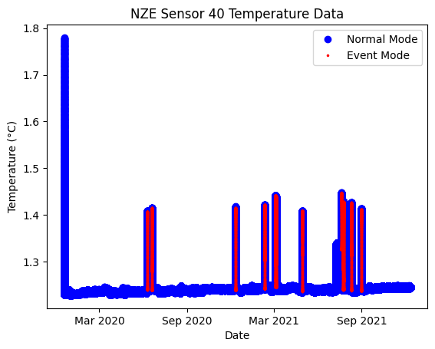
Figure 2 Normal mode temperature data in blue and event mode temperature in red
When event mode is triggered, there is a consistent, sharp increase in temperature. The temperature at which the event mode ends is not as consistent; however, it is always after the peak. This shows that the switch to event mode does cause the device to produce more heat, affecting the data. If this data is to be used to study the deep ocean, data relating to event-mode should be cleaned. It should be noted that the temperature does not immediately return to normal upon event mode termination, as shown in Figure 3. This means that simply excluding data associated with the exact time event mode starts and ends will still leave traces in the data. It should be additionally noted that event mode will be triggered without a sharp change in pressure sometimes; this could be done for testing purposes, regardless of whether the data is categorised under an event mode.
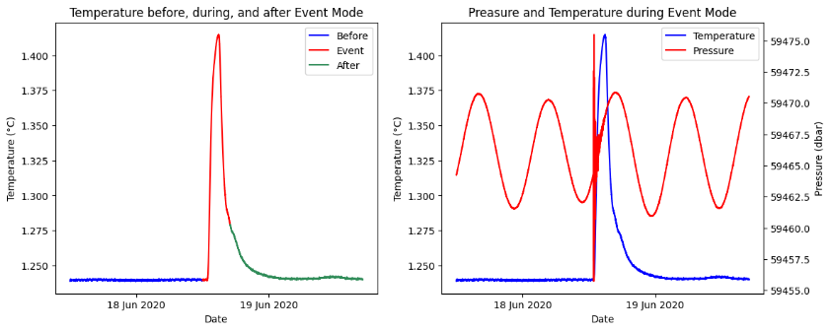
Figure 3 – Left highlights the period before, during, and after the event mode. The right shows the corresponding changes in pressure during the period
Investigating the temperature spike at the beginning of the data was to see if the BPR had recorded any temperature data during the descent. The hope was that if it did, height data would have also likely been recorded and combined, which could form a vertical temperature profile.
Figure 4 shows the first 7 days of temperature and height data revealing a negligible difference in height throughout the 7 days. Though height peaked at the start, the range of height was less than 2m, nowhere near the amount needed for this degree of change in temperature. This temperature spike is likely related to the testing or setup process of the device rather than a temperature difference due to different layers of the ocean.
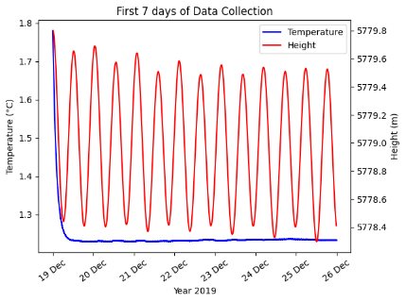
Figure 4 – The first 7 days of data, temperature on the left y-axis and height on the right y-axis
On July 9, 2021, a weird anomaly appeared in the data, the temperature increased and stayed between a range of 1.30°C – 1.35°C for 13 days, see figure x. After the 13 days, an event mode was triggered without a change in pressure. After the event mode ended, it returned to its regular temperature. This correlates to the increase in temperature in Figure X without an event mode correlating with its duration. This is important to mention as it is another type of anomaly that would need to be cleared if the dataset were to be used. From the nature of the pattern, this could have been a software update that triggered the temperature increase and ended with a test of the event mode. Alternatively, something could have been wrong with the device, and a manual trigger of the event mode fixed it.
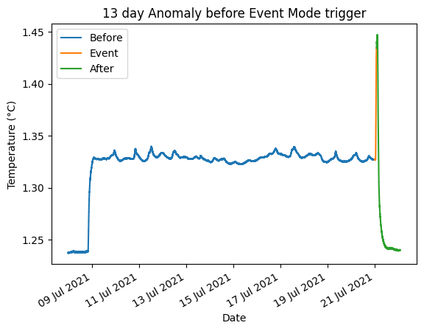
Figure 5 – Mysterious increase in temperature on 9 July 2021
A correlation graph between temperature and pressure yields interesting results in Figure 6. The most eye-catching feature on the is the line that forms toward the top right. This line correlates to the spike at the start of the data. The peak pressure along this line is also similar to other points in the graph, which further supports that the initial temperature spike is not due to temperature recording of different layers of the ocean.
The next most interesting feature on the graph is the box-shaped pattern. The top and bottom walls of the box are determined by pressure. The position of these walls likely relates to the natural peaks and troughs of waves. The left and right wall of the box is determined by temperature. The left wall is likely the normal state for the BPR, given how many points there are. The right wall is likely the peak temperature during an event mode trigger; the side parabolic pattern with maximum along this wall also supports this idea.
Other noticeable patterns are the large number of points on the left wall that are high and low in pressure. These points would have had a steady increase or decrease in pressure such that there was no sudden change in pressure to trigger event mode, allowing it to be recorded with low temperatures. The last noticeable pattern is in the middle of the box. There is a large number of points along a single temperature value between 1.3°C – 1.4°C. This likely correlates to the previously mentioned anomaly on July 09 2021, as it is the only consistent data point at this temperature value.
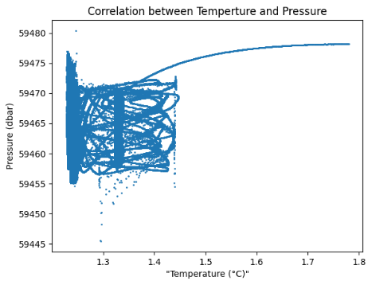
Figure 6 - Correlation graph between temperature and pressure
Pressure is a function of depth in the ocean; the deeper the depth, the greater the pressure. As expected, examining the correlation between pressure and height data reveals a strong correlation.
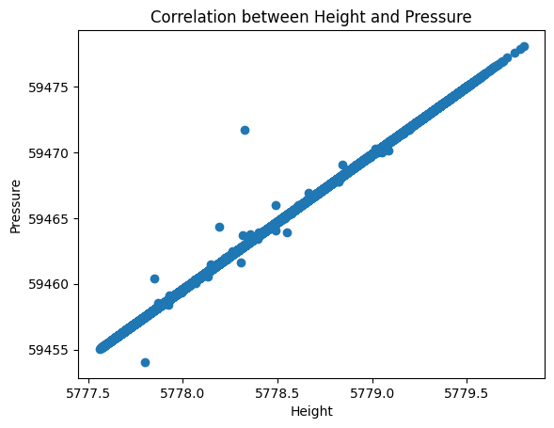
Figure 7 - Correlation graph between height and pressure

Sensor Comparison
Understanding the data of station NZE’s sensor 40, we can start comparing it with other sensors. The NZE station has 3 sensors, 40, 41, and 42. A new sensor code is given every time the BPR is resurfaced for maintenance. As of this report, station NZE is active with sensor 42. As previously mentioned, temperature data is stored in the device data and is only available after each maintenance. This means that only temperature data for sensors 40 and 41 is available, while sensor 42 is not yet available. Comparing the temperature data of these two sensors in Figure 8, clear differences are evident. The average of sensor 41 is 0.10°C higher than sensor 40.
 | NZE 40 | NZE 41
Latitude | -36.0493° | -36.0499°
Longitude | -177.708° | -177.697°
Height | -5779m | -5777m
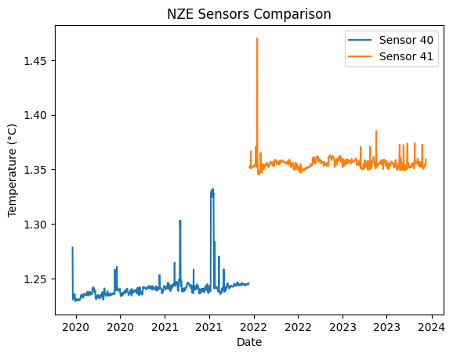
Table 1 – Location of station NZE sensors
Figure 8 – Daily temperature data of station NZE sensors
Using the coordinates of each sensor provided by GeoNet, see table 1, a simple Pythagoras calculation can be made.
$$\sqrt{{\left(111.320km*0.0009°\right)}^{2}+{\left(111.320km*cos\left(0.0011°\right)\right)}^{2}}= 13.908m$$
Sensor 40 and sensor 41 were placed 13.908m apart with sensor 41 being elevated 2m higher. Considering the vastness of the ocean and the stability of deep ocean temperatures, it is highly unlikely that a 13.908m displacement would cause a nearly ~10% change in temperature. It is more likely that some change in the equipment, be that the main components or the temperature sensor, was the cause of this change.
Examining the temperature data from all sensors at all stations (see Figure 9), a shift in temperature data after maintenance is observed in many cases. Some stations experienced similar increases in temperatures, others experienced a decrease in temperatures, some looked to have no significant change, while station NZJ nearly had a 2°C jump in temperature. All the maintenance seems to have been done at three distinct points in time, one near the start of 2022, one in the middle of 2022, and one in the middle of 2023. All of which resulted in varying changes in temperature, and each set of maintenance showed no trends. It is difficult to say what the cause is just from the data alone. If I had to guess, it would be that the temperature sensor got shifted, assuming there is no standard location for it. It is unlikely the cause being equipment upgrades, as it would likely show some type of trend. If this data were to be used as accurate deep ocean temperature data, a lot of work would need to be done to recalibrate each sensor's data to an accurate norm.

Data reliability & Argo Data
Now that we understand what is going on within the datasets, we can examine their reliability in comparison to other, more well-known data sources. From the deep Argo data, there are some data points that are close to the location of our station that can be used. Comparing the available data points to the GeoNet data on Figure 10, we can see a clear disparity in the temperature profiles. The GeoNet data is consistently ~1°C higher than the Argo data. This outcome is not surprising, considering that sensors have varying temperature readings; it would not be reasonable to expect one to accurately record the true temperature unless it were by chance.
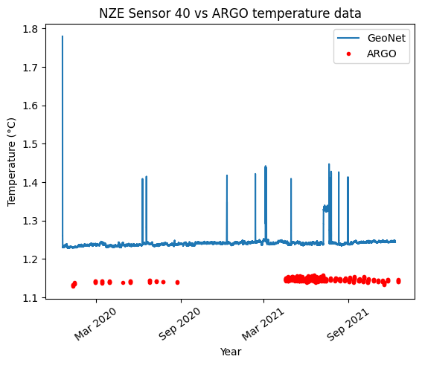
Figure 10 – Argo temperature data in red and DART temperature data in blue
Though direct temperature measurements are not reliable, changes within the data could be useful. Take the range shown in Figure 11 for example. Argo had a data range of 0.028°C, while NZE sensor 40 had a data range of 0.025°C. The data ranges are quite similar; this could mean that changes in temperature data could tell a story about the surrounding temperatures. Having a similar range is not enough to make it reliable for representing temperature changes; it is uncertain whether this is caused by changes in the surrounding water temperature or if the device simply produces heat, causing a similar range.
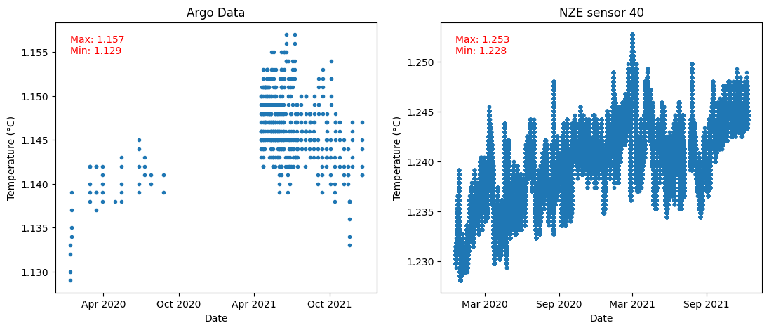
Figure 11 – Left is the Argo data, and right is the DART data with outliers removed. The maximum and minimum range is the top right of each graph

Data Patterns
Examining diurnal variation reveals clear natural and human patterns. Each hour starts with a temperature spike and ends with a temperature drop. This pattern is consistence every hour without fail, and is highly likely to be related to the operation of the device. Without more details of the inner workings of the device from GeoNet, it is difficult to determine if there are any unaffected data points within an hour. As previously mentioned, the DART network transmits data every 6 hours in normal mode (Geonet, n.d.). Interestingly, I could not find any 6-hour pattern with temperatures. Perhaps the online information is incorrect, or the transmission of data produces very little heat.
The natural pattern within a diurnal cycle is a sinusoidal pattern. This pattern is present each day, but the strength and definition varies. The sinusoidal shape leads me to believe that this is caused by the Earth's spin and the gravitational pull of the Moon and Sun, similar to the tidal bulges. Further investigation with lunar and solar phase data could yield very interesting results.
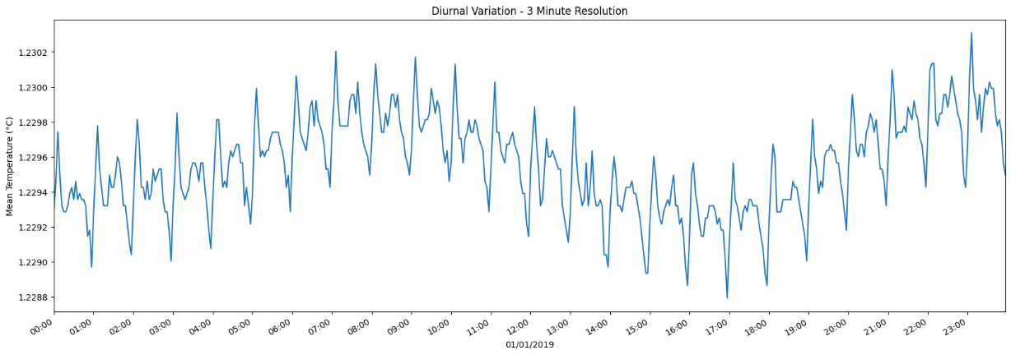
Figure 12 – The daily temperature on 01/01/2019 with points grouped into 3-minutes intervals
Examining the data on a yearly timescale, I found no discernible patterns. I specifically searched for yearly seasonal variations and monthly lunar variations. Considering the gravitational pull theory suggested when discussing the diurnal variation. The lack of patterns could suggest that the moon and tilt of the Earth have little influence compared to the sun in the deep ocean temperature.
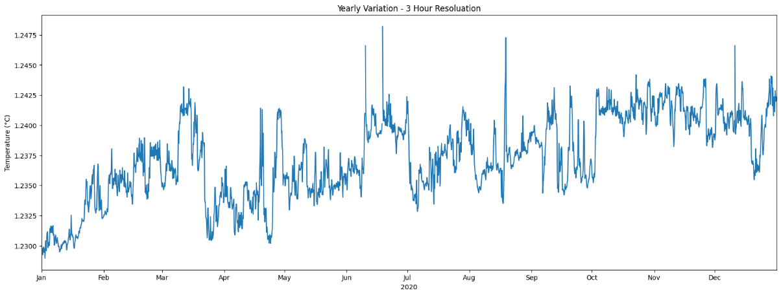
Figure 13 – 2020 yearly temperature with points grouped into 3-hours intervals

Conclusion
The DART Network temperature data from GeoNet contains a significant amount of noise and requires extensive processing to be useful. Such as the triggering of event mode, causing the temperature to rise. The temperature spike at the beginning of the datasets is caused by the initiation after maintenance, and not due to different ocean layers. Additionally, there is an unexplained anomaly on station NZE sensor 40 on 09 July 2021. Using the data below an hourly resolution would need further work in understanding the inner software of the device.
The similar data range to the deep Argo data gives prospects for the dataset. A similar data range could indicate that the dataset can be used to detect changes in the deep ocean despite having a different average; further work is needed to understand the origin of the temperature in the device. The sinusoidal pattern in the diurnal cycle is evidence that there is useful information captured within the data. Further work with lunar and solar cycle data could further confirm this, this work could also be helpful in identifying if there are factors causing the strength of the sinusoidal pattern to vary.

List of References
Abraham, J. P., et al. (2013). A review of global ocean temperature observations: Implications for ocean heat content estimates and climate change. Reviews of Geophysics, 51(3), 450–483. https://doi.org/10.1002/rog.20022
Argo (2025). Argo float data and metadata from Global Data Assembly Centre (Argo GDAC). SEANOE. https://doi.org/10.17882/42182
Argo Program. (n.d.). About. Scripps Institution of Oceanography, University of California San Diego. Retrieved August 18, 2025, from https://argo.ucsd.edu/about/
Carter, L. (1997). The sedimentary regime beneath the deep western boundary current inflow to the Southwest Pacific Ocean. Journal of Sedimentary Research, 67(6), 1005–1017. https://doi.org/10.1306/d42686b2-2b26-11d7-8648000102c1865d
Carter, R. M. (1997). The sedimentary regime beneath the Deep Western Boundary Current inflow to the Southwest Pacific Ocean. Journal of Sedimentary Research, 67(6), 1005–1017. https://doi.org/10.1306/D4268676-2B26-11D7-8648000102C1865D
Geonet. (n.d.). DART (Deep-ocean Assessment and Reporting of Tsunami). https://www.geonet.org.nz/about/tsunami/dart
GNS Science. (2023). Deep-ocean Assessment and Reporting of Tsunami (DART) network [Dataset]. GeoNet. https://doi.org/10.21420/8TCZ-TV02
Internet Geography. (n.d.). What is global atmospheric circulation? Retrieved August 16, 2025, from https://www.internetgeography.net/topics/what-is-global-atmosphericcirculation/
Lozier, M. S. (2010). Deconstructing the Conveyor Belt. Science, 328(5985), 1507–1511. https://doi.org/10.1126/science.1189250
MetService. (n.d.). Sea surface temperature. Retrieved August 18, 2025, from https://www.metservice.com/maps-radar/marine/sea-surface-temperature
Mortimer, N., Campbell, H. J., Rowland, J., Carlow, M., & The Z. (2017). Zealandia: Earth's hidden continent. GSA Today, 27(3), 1–6. https://doi.org/10.1130/GSATG321A.1
National Emergency Management Agency. (n.d.). How does the DART network work? [Infographic]. New Zealand Government. https://www.civildefence.govt.nz/assets/Uploads/publications/tsunami/DARTnetwork-infographic.pdf
NIWA. (2008). Linking the world's oceans: the Antarctic Circumpolar Current. Water & Atmosphere, 16(4), 24–25. Retrieved August 17, 2025, from https://niwa.co.nz/sites/default/files/import/attachments/oceans.pdf
NIWA. (n.d.-a). Copyright and conditions of NIWA data access and use. Retrieved August 18, 2025, from https://niwa.co.nz/climate-and-weather/copyright-andconditions-niwa-data-access-and-use
NIW (n.d.-b). NOAA satellite data. Earth Sciences New Zealand. Retrieved August 18, 2025, from https://niwa.co.nz/atmosphere/noaa-satellite-dataA.
Pauthenet, E., Roquet, F., Madec, G., Sallée, J.-B., & Nerini, D. (2019). The thermohaline modes of the global ocean. Journal of Physical Oceanography, 49(10), 2535–2552. https://doi.org/10.1175/JPO-D-19-0120.1
Sathyanarayanan, A., Köhl, A., & Stammer, D. (2021). Ocean salinity changes in the global ocean under global warming. Journal of Climate, 34(20), 8219–8236. https://doi.org/10.1175/JCLI-D-20-0865.1
Silvano, A., Purkey, S., Gordon, A. L., Castagno, P., Stewart, A. L., Rintoul, S. R., Foppert, A., Gunn, K. L., Herraiz-Borreguero, L., Aoki, S., Nakayama, Y., Naveira Garabato, A. C., Spingys, C., Akhoudas, C. H., Sallée, J.-B., de Lavergne, C., Abrahamsen, E. P., Meijers, A. J. S., Meredith, M. P., … Lee, W. S. (2023). Observing Antarctic Bottom Water in the Southern Ocean. Frontiers in Marine Science, 10. https://doi.org/10.3389/fmars.2023.1221701
Webb, P. (2021). 8.1 Earth's heat budget. In Introduction to Oceanography. RWU Pressbooks. https://rwu.pressbooks.pub/webboceanography/chapter/8-1-earthsheat-budget/
Zika, J. D., Skliris, N., Nurser, A. J. G., Josey, S. A., Mudryk, L., Laliberté, F., & Marsh, R. (2015). Maintenance and broadening of the ocean’s salinity distribution by the water cycle. Journal of Climate, 28(24), 9550–9560. https://doi.org/10.1175/JCLI-D-150273.1

